# INSTALLATION OF HADOOP

* 1. **Install Apache Hadoop**

Download the latest version of Apache Hadoop from official website.

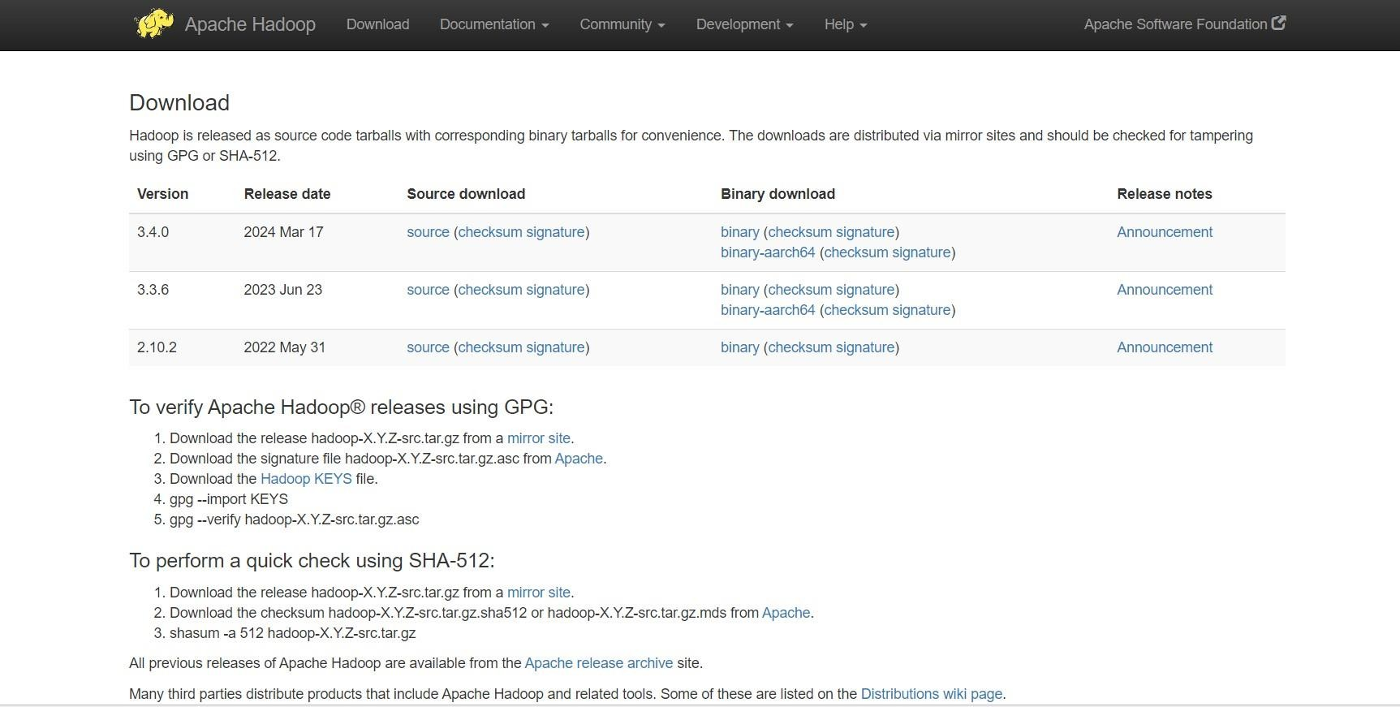

# Setting Up Environment Variables:

Go to edit environment variables, and select environment variables to set up the environment variables

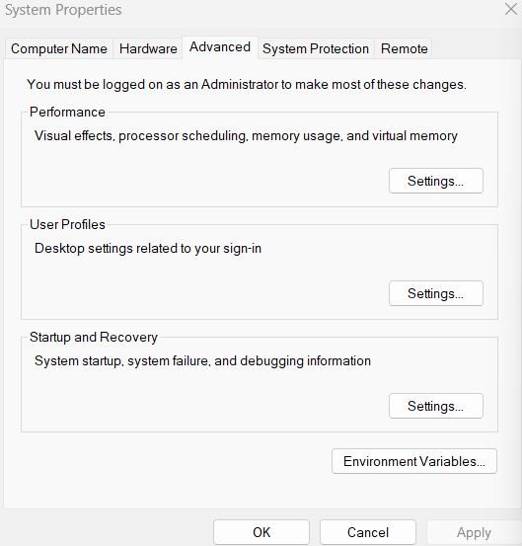

# Setting JAVA_HOME

* + - Open environment Variable and click on “New” in “User Variable”
    - Now , add JAVA_HOME in variable name and path of Java(jdk) in Variable Value.
    - Click OK and we are half done with setting JAVA_HOME.

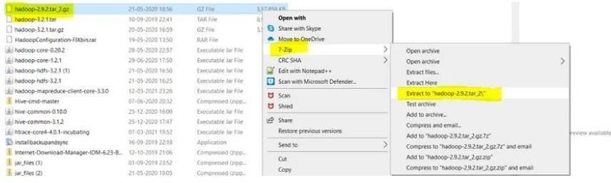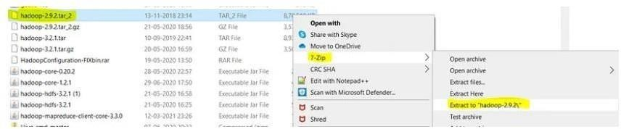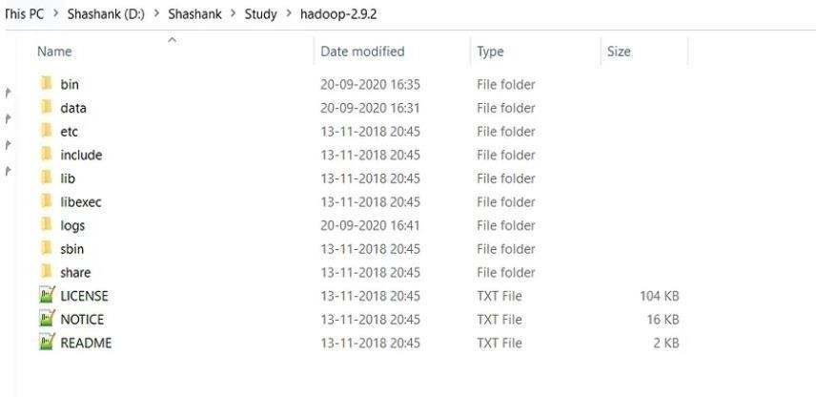

# Setting HADOOP_HOME

* + - Open environment Variable and click on “New” in “User Variable”
    - Now, add HADOOP_HOME in variable name and path of Hadoop folder in Variable Value.
    - Click OK and we are half done with setting HADOOP_HOME.

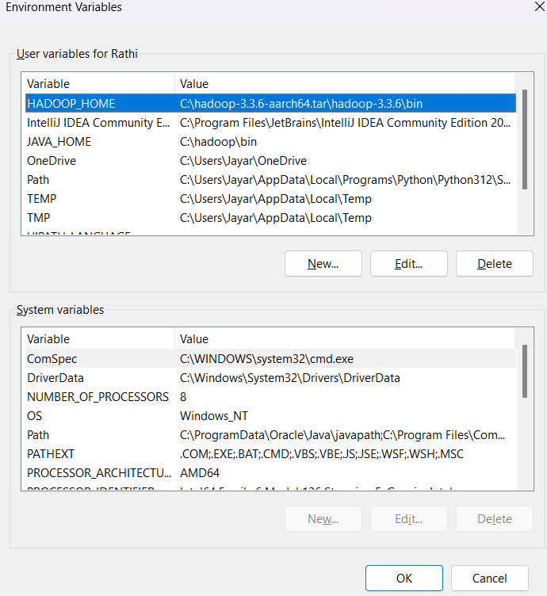

# Setting Path Variable

* + - Last step in setting Environment variable is setting Path in System Variable.
    - Select Path variable in the system variables and click on “Edit”.
    - Now we need to add these paths to Path Variable one by one:-
      * %JAVA_HOME%\bin
      * %HADOOP_HOME%\bin
      * %HADOOP_HOME%\sbin
    - Click OK and OK. & we are done with Setting Environment Variables.

# Verify the Paths

* + - Open a **NEW** Command Window
    - Run following commands. echo %JAVA_HOME% echo %HADOOP_HOME%

echo %PATH%

# Creating Folders

* + - Create **DATA folder** in the Hadoop directory
    - These folders are important because files on HDFS resides inside the datanode.

# OUTPUT:

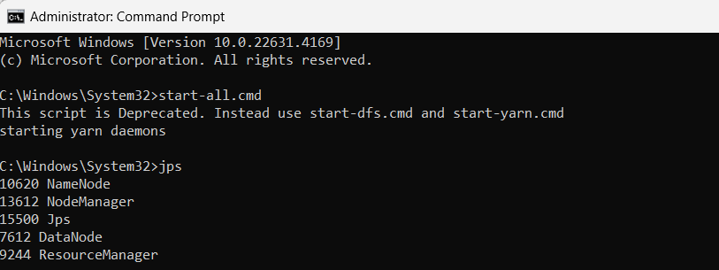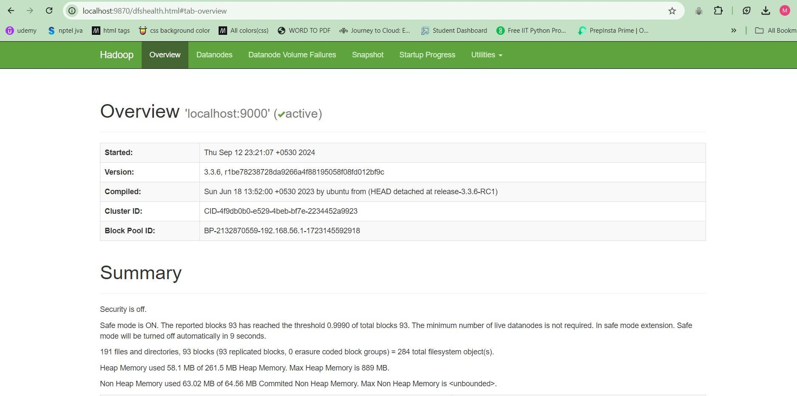

**Result:**

Thus the Apache Hadoop is installed on windows Successfully.